Write With AI
The Trojan Horse Playbook
How I Landed My First $10,000 Email Ghostwriting Client



My first ever email ghostwriting client paid me $10,000 for ONE project.
What was the project?
Building an email course funnel to generate sales of his paid course on autopilot.
Now, here’s the interesting part:
Back then, I didn’t have…
- A fancy funnel
- Any case studies
- Or a big audience
So, how did I “persuade” this person to work with me and, on top of that, pay me a premium?
The Trojan Horse Strategy.

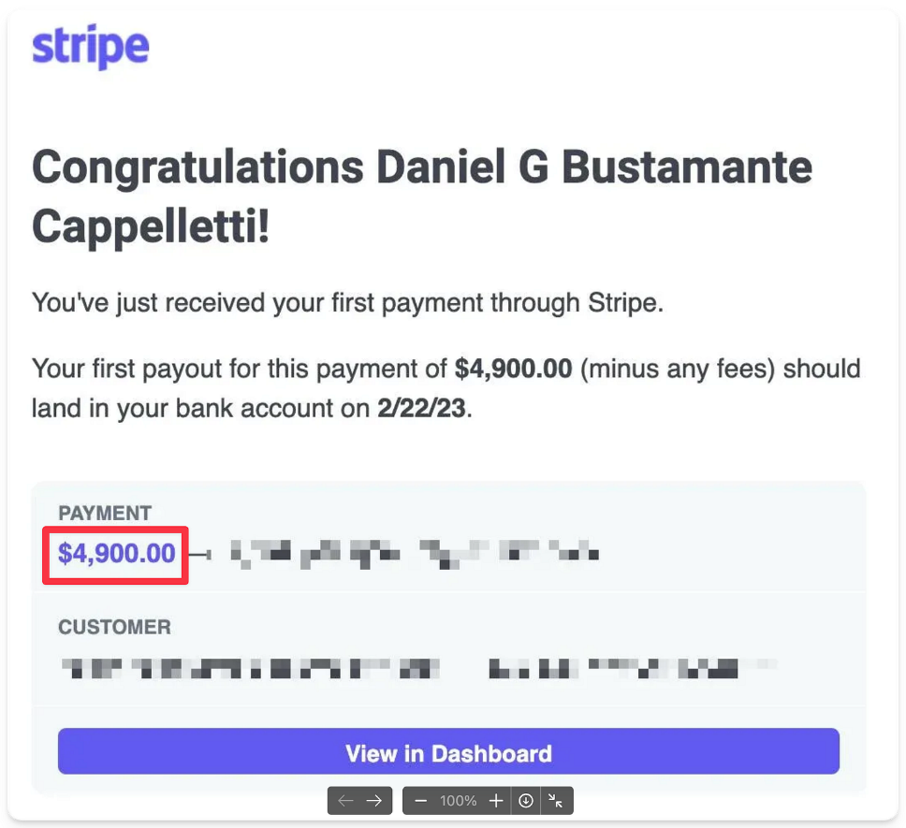

Let’s break it down (so you can do the same):
The Trojan Horse Strategy: Overview
In case you’re not familiar, my name is Daniel Bustamante.
And I’m the COO & email marketing wizard behind a portfolio of 6 & 7 figure education companies in the digital writing space:
- Premium Ghostwriting Academy
- Ship 30 for 30
- Write With AI
Now, I love my job - but I’ve always been very entrepreneurial.
So back in January 2023, I decided to start email ghostwriting on the side.
And at first, I tried the same things everyone does:
Cold DMs and cold emails - tons of them.
But guess what?
Most people just ghosted me (pun intended lol).
The problem was…
My DMs were OK - but they didn’t really stand out.
So, I started asking myself:
“How can I create a message that people actually want to immediately respond ‘yes’ to?”
And after doing some thinking, I arrived at 2 conclusions:
- The message should be highly personalized & relevant to each person I’m sending it to. That will increase the odds people actually read it.
- The message should contain a “Trojan Horse Offer” that people feel stupid saying “no” to. That way, I can get my foot in the door, overdeliver with free value, and them solve another problem in their business (but in the form of a paid project).

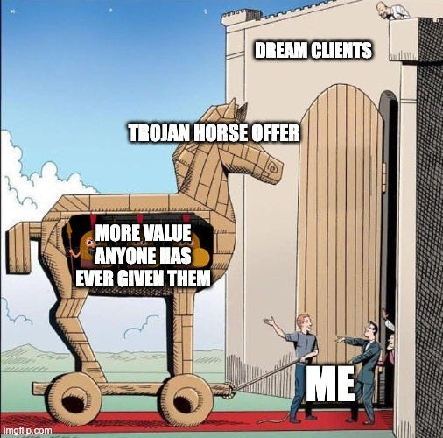

Now, Step #1 is relatively straightforward.
You need to do your homework & craft a nice, very personal email.
(Don’t worry, though, I’ll share some examples of how I did this too so you can draw some inspiration for crafting your own personalized emails/DMs.)
But the second part is more nuanced:
What does it mean to create a great “Trojan Horse Offer”?
For me, a great free offer should be:
- Something you would normally do as part of your full service/package/offer - but is still valuable on its own
- Small enough that you can fulfill it in a few days - but meaningful enough that the client actually wants it
- And something most of your ideal clients need or want (so you can systematize it and do it repeatedly)
Again, your goal here is NOT to make money (yet) - but to get an opportunity to show a potential client (1) how much value you can create in their business and (2) how smooth & easy it is to work with you.
So after reviewing my offer stack and doing some research, I created my first free offer:
A free segmentation survey implementation.
My rationale:
- This was something I was already planning on doing as part of my full package. And even if they didn’t end up hiring me to build the whole thing, they could still benefit from having that in place.
- It would only take me a few days to implement it. So if needed, I could do several of these every month. But also, the prospect would be able to immediately see the value.
- Lastly, I noticed this was a piece most of my dream clients were missing in their funnel. And I knew that, with some education, I could easily “sell” them on the idea.
So, I ran with that.
And in less than a week, I got my first “yes.”
So, I jumped on a call with the guy, got access to all his stuff, and got to work.
And of course, I did everything I could to delight him.
And once I was done fulfilling on my free offer, guess what he said:
“This is epic. What else can you help me with? I’d love to keep working together.”
2 weeks later, he paid me $10,000 to build & ghostwrite an email course funnel for him.
But here’s the best part:
This strategy didn’t just help me land this one client.
It’s actually landed me most of my “outbound” clients—and has helped me generate me over $100,000 in ghostwriting income (and mind you: I do this as a side hustle, it’s not my main thing).
And just in case—here’s some proof :)

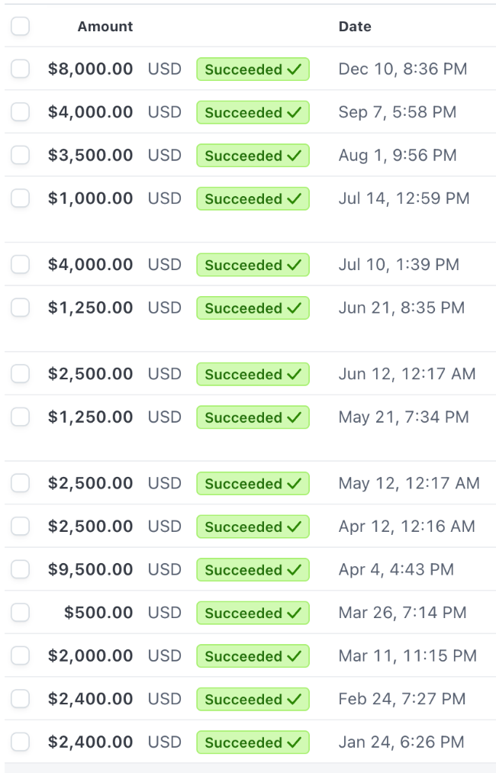

So I know it works.
Which is why I wanted to share it with you.
Now, as you can see, this requires some “thinking.”
The good news?
I’ve created a step-by-step checklist (which also includes some AI prompts & real-world examples) to help you streamline this whole process—so you can create your own Trojan Horse Offer 10x faster.
Here are the steps:
- Break down your current offer stack
- Brainstorm "Trojan Horse Offers" with AI
- Research your ideal clients
- Pick your “Trojan Horse Offer”
- Create your "Trojan Horse Offer" DM/email scripts
- Start pitching your "Trojan Horse Offer" (script template)
- Overdeliver on your "Trojan Horse Offer"
- Upsell your client
So, are you ready?
Let's dive in.

Step #1: Break down your "offer stack"
This is pretty straightforward - but it's crucial you get it right.
Grab a piece of paper (or open a new doc) and brain dump every single deliverable you provide in your paid service.
And I mean everything.
- Those strategy sessions you do? Write 'em down.
- The implementation work? Yep.
- Even the small stuff like weekly check-ins or progress reports.
Why?
Because your Trojan Horse Offer needs to be a slice of your actual service - not some random thing you came up with.
Trust me, when you list everything out, you'll start seeing opportunities for Trojan Horse Offers you didn't even realize existed.
The key here is being thorough.
Don't rush this part.
Step #2: Brainstorm "Trojan Horse Offers" with AI (prompt included)
Now this is where the magic happens.
I've created a special AI prompt to help you brainstorm killer Trojan Horse Offer ideas.
Just copy it, fill in your details, and feed it to ChatGPT, Claude, or your favorite AI tool.
Here’s the prompt:
I'm a [your profession/service] who helps [target audience] with [main outcome] through a done-for-you [service name]. Here's my current offer stack (the key deliverables I provide in my paid services):

1. [List your first deliverable]
2. [List your second deliverable]
3. [Continue listing all key deliverables]

My typical project size/scope is [describe typical engagement length and price range].

Based on this information, please help me brainstorm 10 potential "Trojan Horse Offers" that meet these criteria:

- Can be completed within 2-3 days
- Delivers standalone value but naturally leads to my full service
- Represents a small portion of my complete offer
- Can be systematized and repeated for different clients
- Addresses a common pain point or gap for my target audience

My goal is to pitch ideal clients on this free offer as way to get my foot in the door, overdeliver with value, and then upsell them on a paid project/engagement.

Now, for each suggestion, please explain:

1. What exactly I would deliver
2. Why it would be valuable to the client
3. How it connects to my larger paid offer
4. What makes it an irresistible "foot in the door" opportunity

Please also highlight any potential challenges or considerations I should keep in mind for each suggestion.
Step #1: Break down your "offer stack"
This is pretty straightforward - but it's crucial you get it right.
Grab a piece of paper (or open a new doc) and brain dump every single deliverable you provide in your paid service.
And I mean everything.
- Those strategy sessions you do? Write 'em down.
- The implementation work? Yep.
- Even the small stuff like weekly check-ins or progress reports.
Why?
Because your Trojan Horse Offer needs to be a slice of your actual service - not some random thing you came up with.
Trust me, when you list everything out, you'll start seeing opportunities for Trojan Horse Offers you didn't even realize existed.
The key here is being thorough.
Don't rush this part.
Step #2: Brainstorm "Trojan Horse Offers" with AI (prompt included)
Now this is where the magic happens.
I've created a special AI prompt to help you brainstorm killer Trojan Horse Offer ideas.
Just copy it, fill in your details, and feed it to ChatGPT, Claude, or your favorite AI tool.
Here’s the prompt:
I'm a [your profession/service] who helps [target audience] with [main outcome] through a done-for-you [service name]. Here's my current offer stack (the key deliverables I provide in my paid services):

1. [List your first deliverable]
2. [List your second deliverable]
3. [Continue listing all key deliverables]

My typical project size/scope is [describe typical engagement length and price range].

Based on this information, please help me brainstorm 10 potential "Trojan Horse Offers" that meet these criteria:

- Can be completed within 2-3 days
- Delivers standalone value but naturally leads to my full service
- Represents a small portion of my complete offer
- Can be systematized and repeated for different clients
- Addresses a common pain point or gap for my target audience

My goal is to pitch ideal clients on this free offer as way to get my foot in the door, overdeliver with value, and then upsell them on a paid project/engagement.

Now, for each suggestion, please explain:

1. What exactly I would deliver
2. Why it would be valuable to the client
3. How it connects to my larger paid offer
4. What makes it an irresistible "foot in the door" opportunity

Please also highlight any potential challenges or considerations I should keep in mind for each suggestion.
But here's the thing: don't just take the first ideas the AI spits out.
Run the prompt 2-3 times.
Mix up how you describe your service.
Play around with different phrasings.
You want to generate at least 15-20 potential Trojan Horse Offers.
Some will be garbage - that's fine.
Others will be gold.
The goal here is quantity first, then we'll filter for quality later.
And don't be afraid to riff off the AI's suggestions - sometimes combining two "meh" ideas creates one killer Trojan Horse Offer.
Once you’re done, move all your ideas over to the same document you used to break down your offer stack.
Step #3: Research your ideal clients
Here's where most people mess up:
They create a Trojan Horse Offer without actually knowing if their dream clients need it.
Big mistake.
You need to do some detective work:
- Go stalk your ideal clients' social media
- Check out their websites
- Join their email lists
- Read their posts
Then, look for patterns:
- What are they all struggling with?
- What are they all trying to achieve?
- What pieces are most of them missing?
Pro tip: Write down all your observations as you go through this process - ideally in the same document you used to break down your offer stack & store your running list of Trojan Horse Offer ideas.
This step is crucial because it helps you validate your Trojan Horse Offer and make sure you’re actually solving a problem they have.
Step #4: Pick your "Trojan Horse Offer"
Alright, decision time.
Look at all the Trojan Horse Offer ideas you've generated and match them against your client research.
And remember - you're looking for this sweet spot:
- Something you can knock out in a few days
- That solves a real problem your dream clients have
- And that naturally leads into your paid offer
Now, 2 additional pro tips here (that could potentially make the “choosing” part easier):
- The weirder, the better. Having a unique Trojan Horse Offer is an amazing way to differentiate yourself from other service providers in your niche/industry. So if possible, try to prioritize Trojan Horse Offers that are not as common or easy to implement for other people.
- The more you like/enjoy the implementation, the better too. Even though this strategy is extremely effective, that doesn’t mean you will only use it once. You’ll be constantly pitching people on your Trojan Horse Offer as you continue to grow your client roster. So pick something you won't hate doing over and over.
Step #5: Create your "Trojan Horse Offer" DM/email scripts
Let's make this crystal clear: our outreach needs to be so personalized that it feels like you wrote it just for them (because you did).
Start with a killer opening that proves you've done your homework.
Then, present your Trojan Horse Offer as a natural solution to something they're already working on or talking about.
But here's the key: make the offer feel exclusive and time-sensitive.
Not in a sleazy way, but in a "I noticed X and had this idea specifically for you" way.
Your message should make them feel special and make saying "no" feel like a missed opportunity.
Step #6: Start pitching your "Trojan Horse Offer" (script template)
Time to put yourself out there.
But here's the thing about pitching your Trojan Horse Offer: it's not about volume, it's about precision.
Pick 5-10 dream clients and focus on them.
Let me show you exactly how this works with a real example that landed me multiple paid projects.
Here's a real-life example from a Trojan Horse Offer DM I sent last year (which ended up converting and leading to 2 paid projects later):

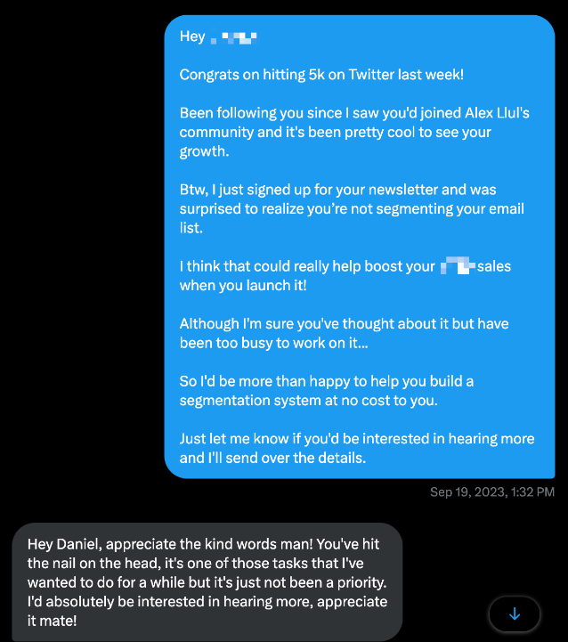

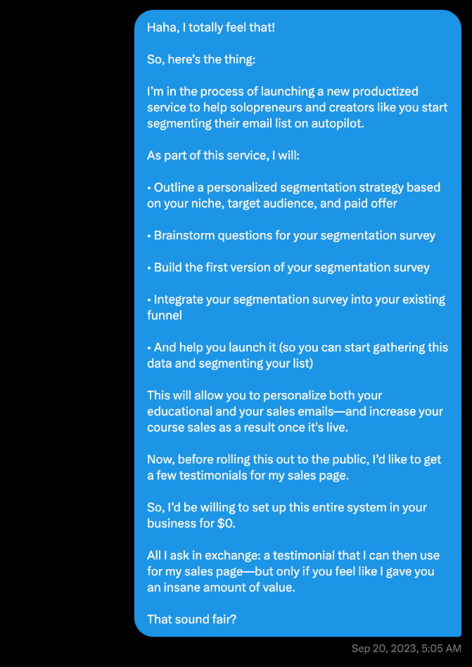

Now, let's break down why this worked.
Every killer Trojan Horse Offer pitch follows this structure:
- Personal opener (shows you've done your homework)
- Specific observation about their business
- Identify a gap/opportunity
- Connect it to their goals
- Acknowledge why they haven't addressed it
- Present your Trojan Horse Offer
- Low-pressure call to action
Then, once they show interest, you want to follow up with the specifics like I did:
- Outline exactly what they'll get
- Show how it connects to their goals
- Be clear about what you want in return
- Keep it feeling exclusive
Here's a quick template you can use as a starting point:
Hey [Name]!

Congrats on [recent achievement]!

[Personal connection point - how you found them/have been following them]

I noticed [specific observation about their business]

I think [connect observation to their known goal]

Although [empathetic assumption about why they haven't addressed it]

So I'd be happy to [your Trojan Horse Offer]

Just let me know if you'd like to hear more details.
Step #7: Overdeliver on your "Trojan Horse Offer"
This is where you turn skeptics into believers.
When someone says "yes" to your Trojan Horse Offer, you need to blow their mind with how much value you deliver.
Not by doing extra work - but by doing the promised work at an insanely high level.
- Be FAST
- Explain your thinking
- Document everything
- Show them the strategic considerations behind your tactical work
Your goal is to make it IMPOSSIBLE for them not to think…
"Wow, if this is what they do for free, imagine what their paid work is like."
That's the reaction you're going for.
Step #8: Upsell your client
Here's the beautiful part:
If you've done steps 1-7 right, this part often happens naturally.
The client already sees the value.
They trust your expertise.
And they're usually the ones asking "what else can we do together?"
But don't leave it to chance.
Have a clear next step in mind.
When you’re done implementing your Trojan Horse Offer, get on a call with the client so you can:
- Break down everything you built for them.
- Remind them of how this is going to benefit them (whether you continue working together or not).
- And walk them through the next logical step—and how you could help them implement that through your paid offer.
Again - the nice thing is that, at this point, you already did most of the heavy lifting by overdelivering on your Trojan Horse Offer.
So the chances of you closing the deal & upselling the client are actually VERY high.
And that’s it!
Now the ball is in your court.
What are you gonna do?
Are you going to implement this playbook so you can start landing high-paying clients?
Or are you going to come up with an excuse as to why this won’t work for you?
I hope it’s the former.
Cheers,
Daniel

